ASSIGNMENT - DIGITAL MARKETING

|  |  |
| --- | --- |
| Reg No | 962820106013 |
| NAME | ASMITHA.M.A |
| NM ID | E9B68A02BEC17668A114A83799142494 |
| Date | 20-10-2023 |

1.Create a blog or website using Blogspot and WordPress. Customize the theme design and post new article with 500 words.

Link: https://asmijames.blogspot.com/

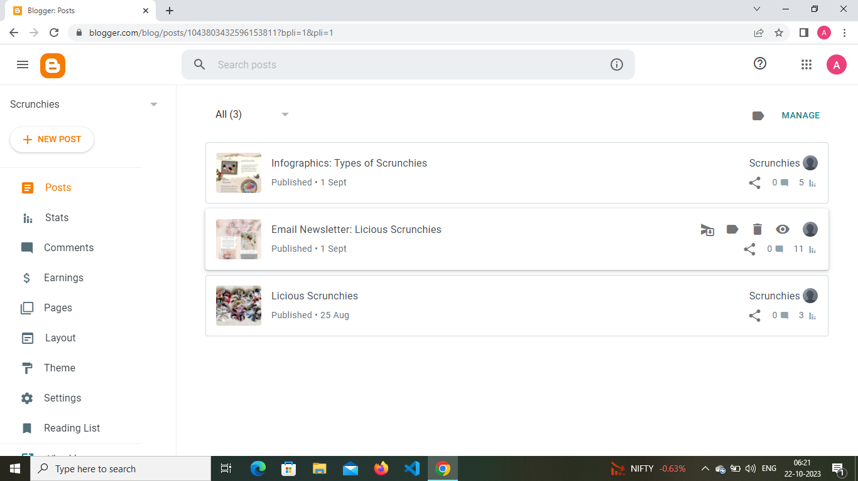

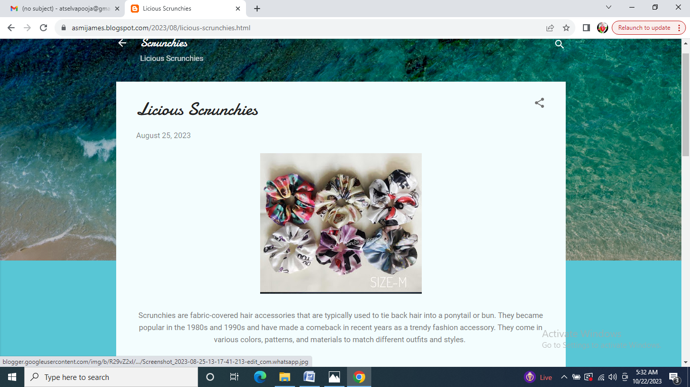

**2**.Create a new facebook page and post one social media poster for your brand.

Link: https://www.facebook.com/profile.php?id=61550677402422&mibextid=ZbWKwL

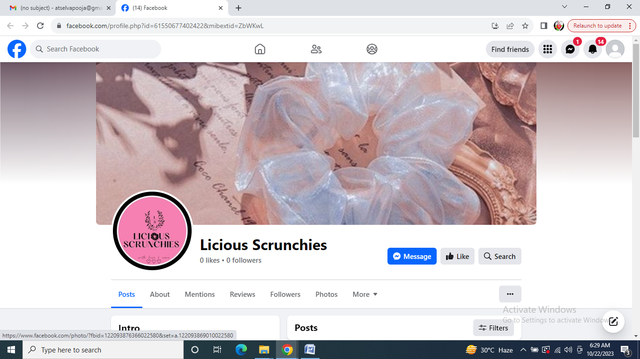

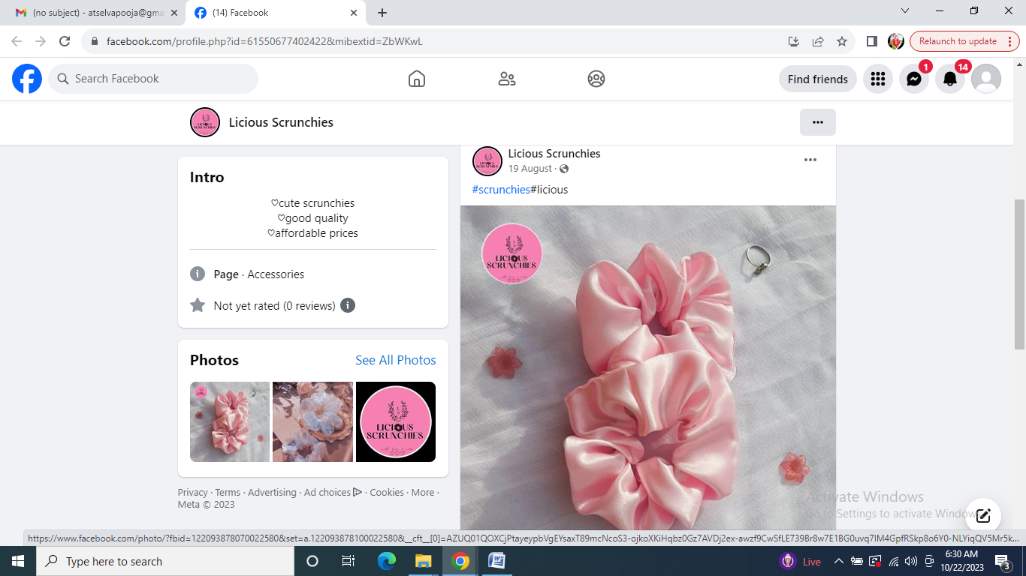

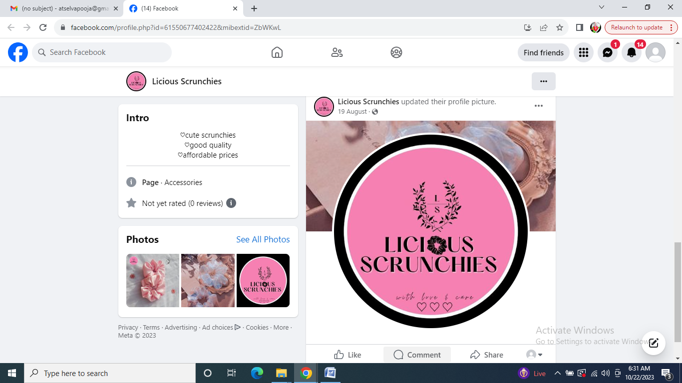

**3**.Create and design a social media advertisement poster using canva

Link: https://www.canva.com/design/DAFx-xs1KCk/KAiglzTDyqWXbzAtuJDT7Q/edit?utm_content=DAFx-xs1KCk&utm_campaign=designshare&utm_medium=link2&utm_source=sharebutton



4.Create email newsletter design using MailChimp or canva tool.

Link:Using canva

https://asmijames.blogspot.com/2023/09/email-newsletter-licious-scrunchies.html



